User Manual for the user who use this website:

1. The first step is after you see the readme.txt ; and login the website through username and password provided as username: admin and password: admin

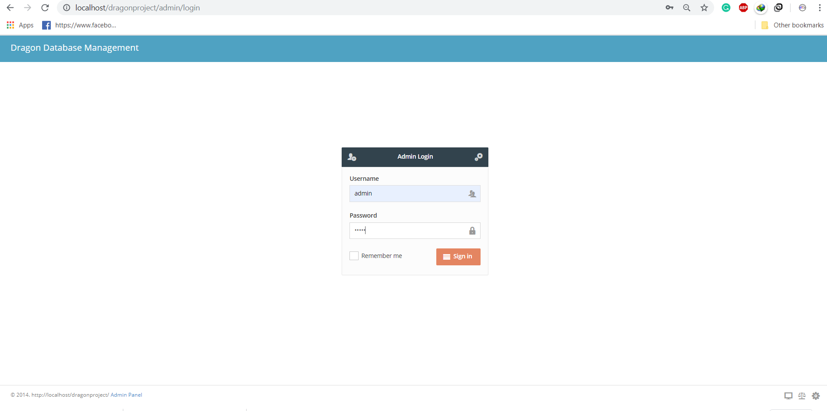

**Password**

**Username**

1. You will enter to the dashboard page where you can query the dragon profile. Here you can add the information and search.

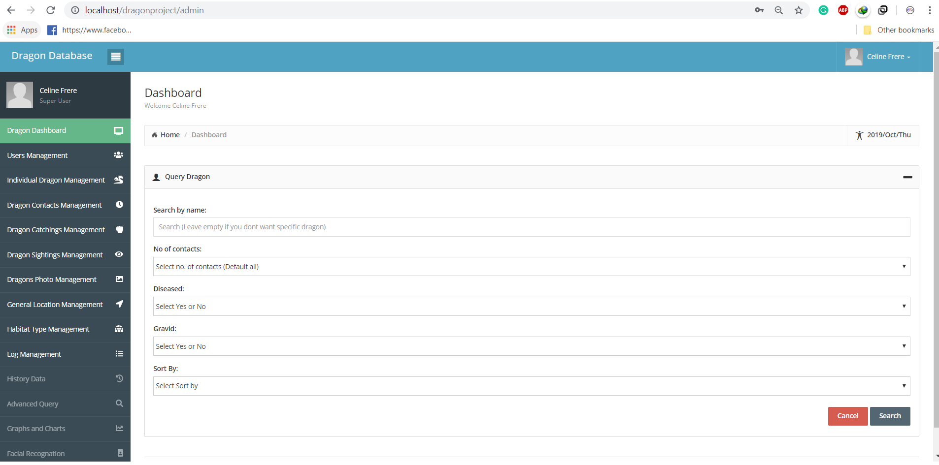

**Search**

**1. order list**

1. After you search dragon profile you can view and download the dragon information. Here you can download dragon information in csv format.

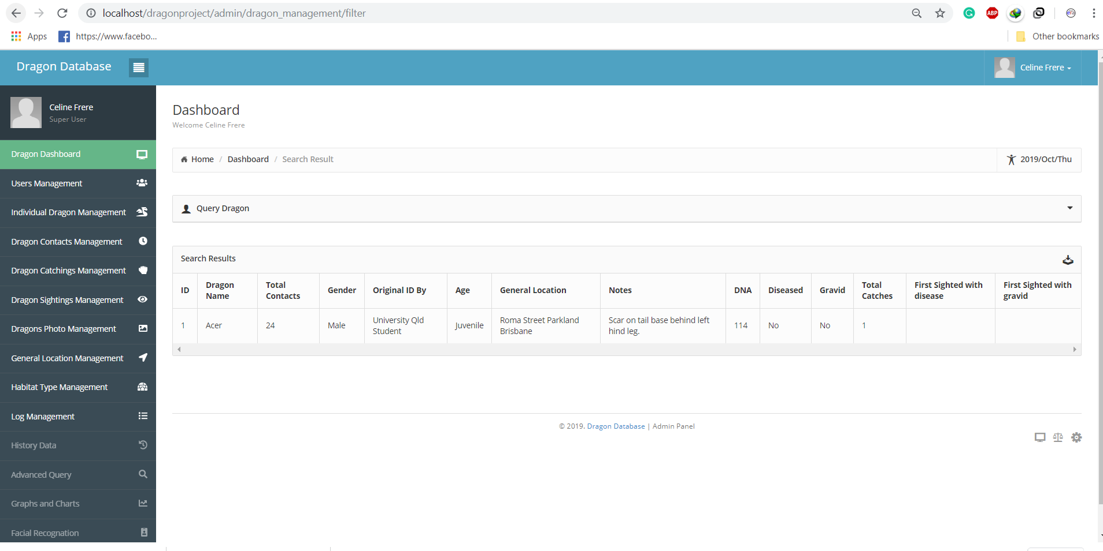

**Download**

1. Go to the User Management there you can modify, add, activate or deactivate the user.

The plus sign is the add option where admin can add the user.

The pen sign is the modify option where user can edit/update the user details.

Activate button will activate the user.

**Add**

**Modify**

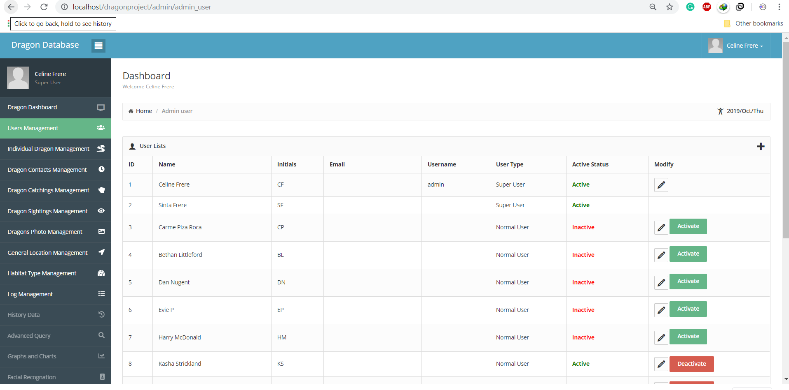

**Activate/Deactivate**

1. In the Individual dragon management user can add/view/edit and delete the individual dragon information.

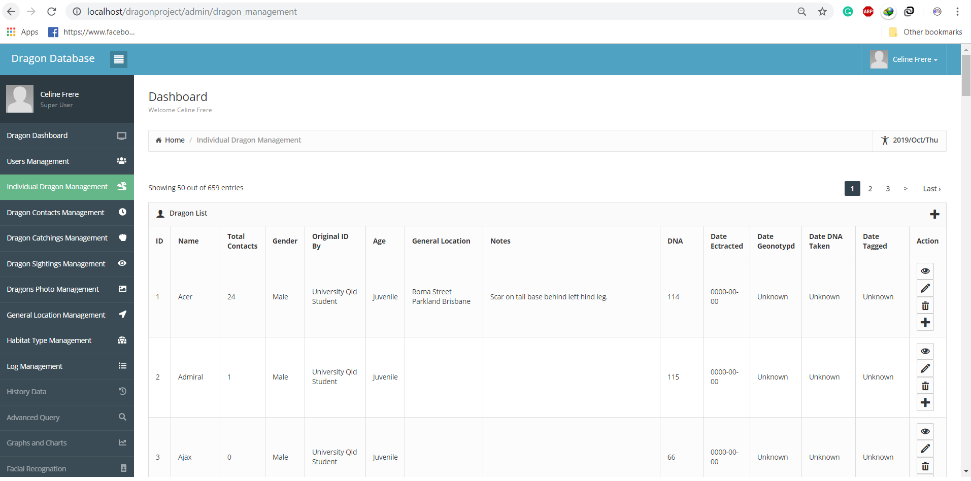

**Add**

**View**

**Add**

**Edit**

**Delete**

1. In the Dragon contact Management user can add photo /view existing data/edit data and delete the data

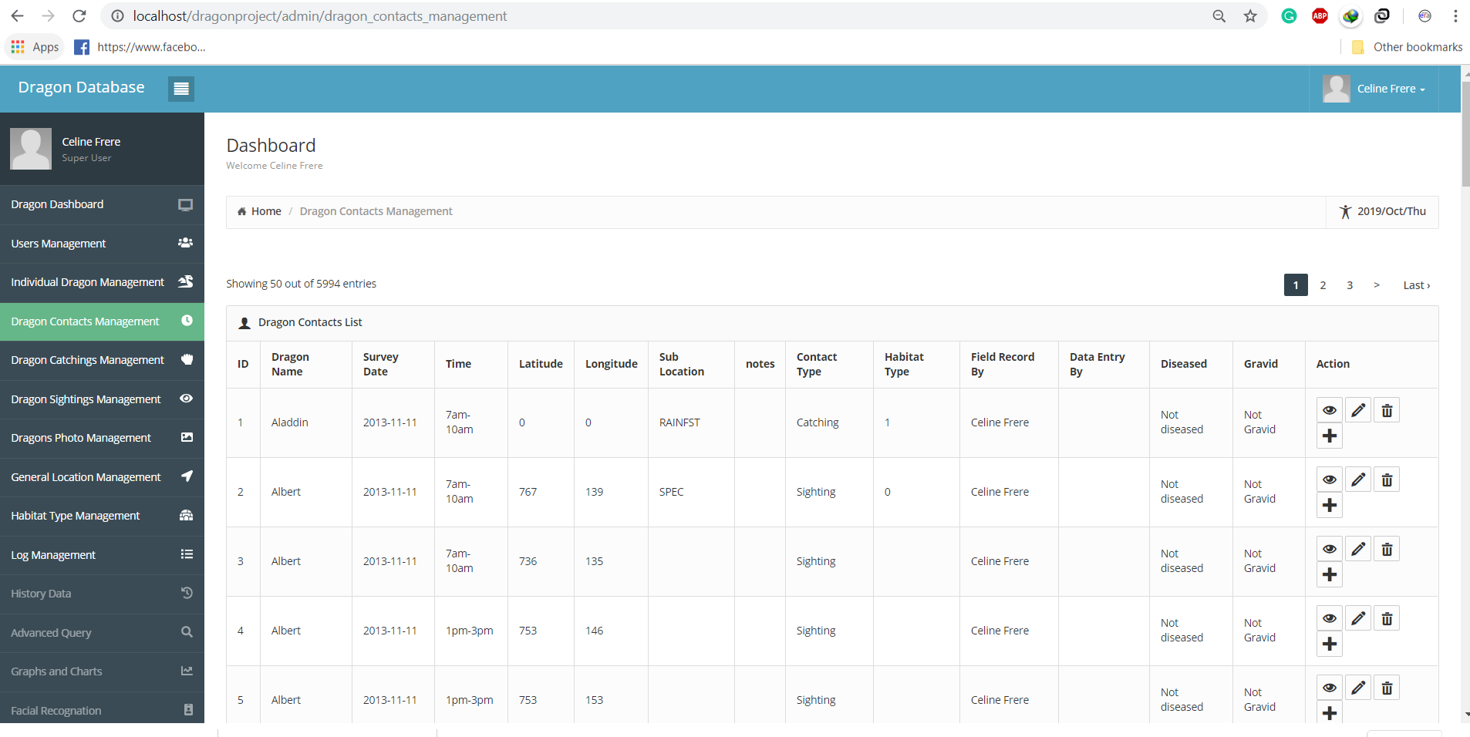

**Add photo contact**

**Delete**

**Edit**

**View**

1. In the Dragon catching Management user can view, edit and delete the dragon details.

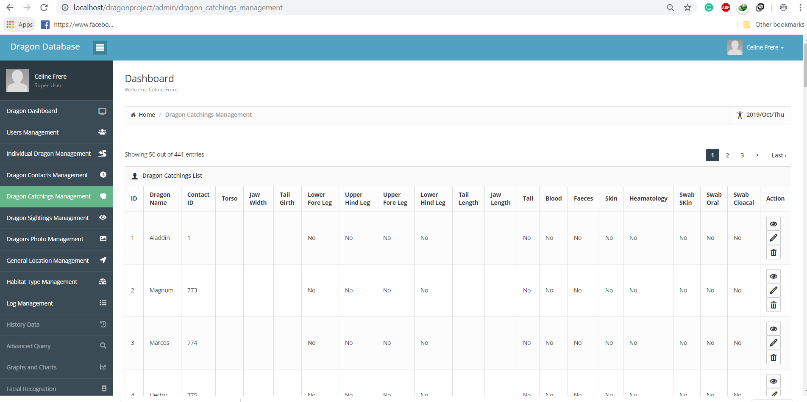

**Delete**

**Edit**

**View**

1. In the Dragon siting Management user can view, edit, and delete the dragon details.

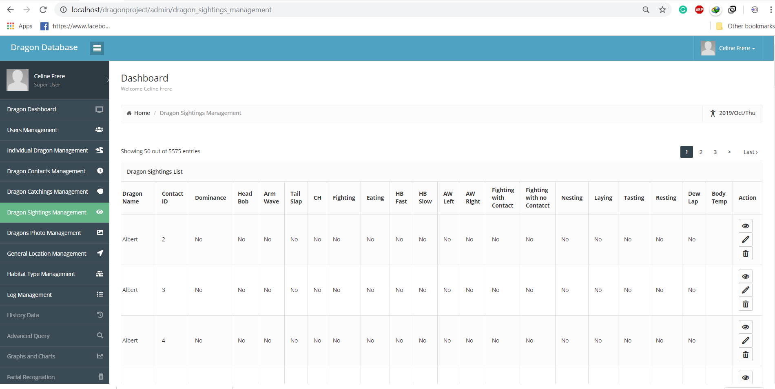

**Edit**

**View**

**Delete**

1. In the dragon profile management user can view / download and delete the dragon contacts photo.

**Download**

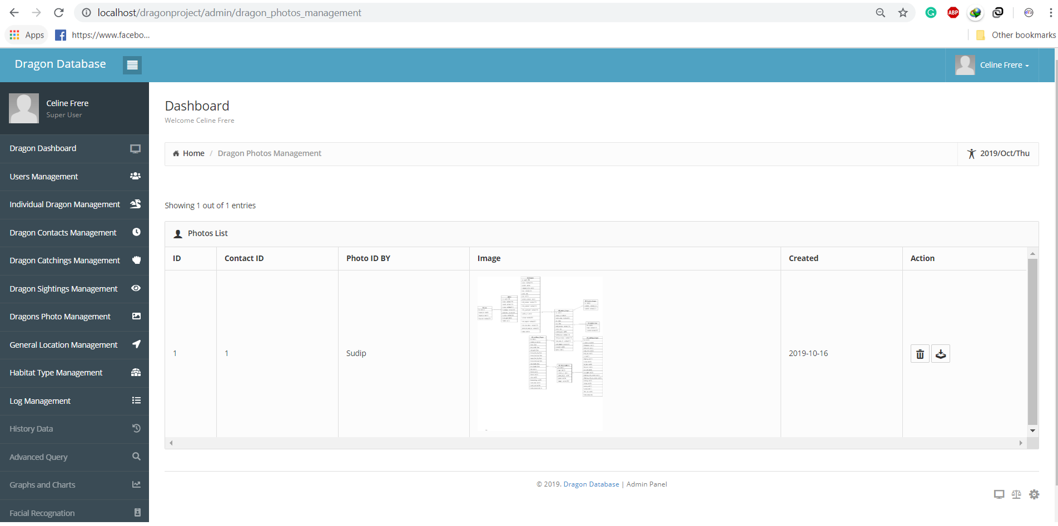

**Delete**

1. In the general location management you can add/edit and delete the dragon general location.

**Delete**

**Add**

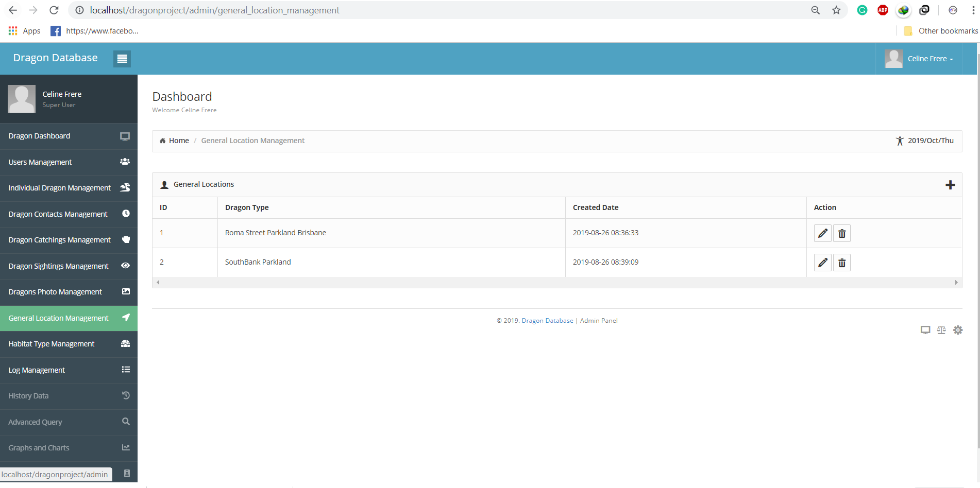

**Edit**

1. In the habitat type management user can add/edit and delete the habitat type management

**Delete**

**Edit**

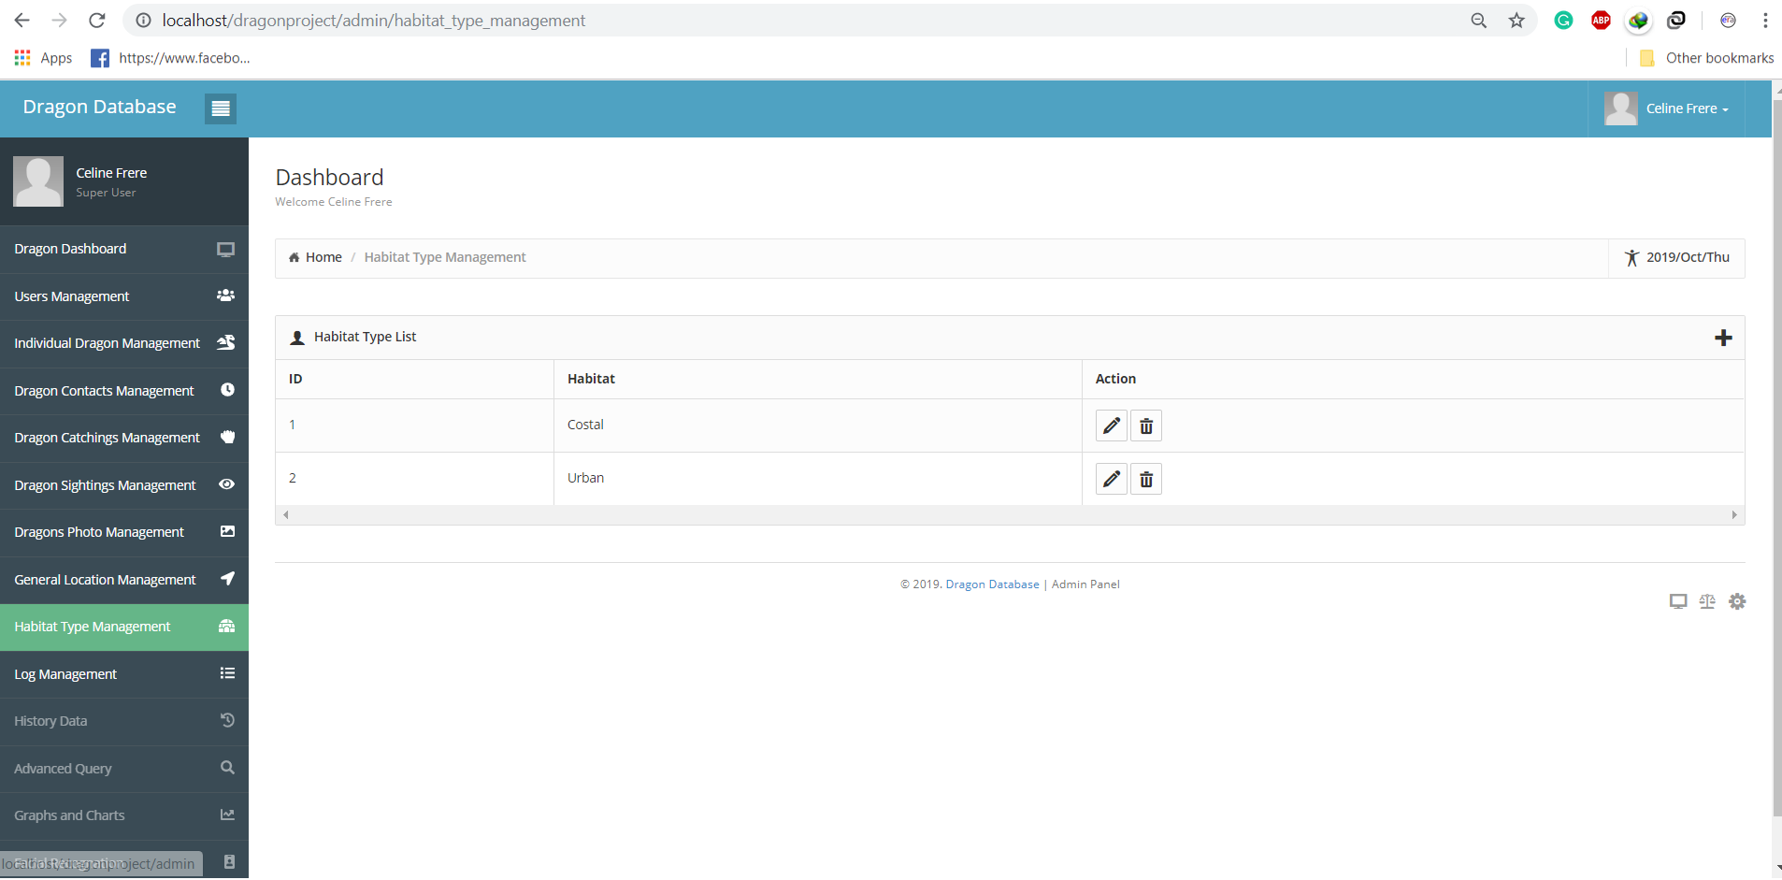

**Add**

1. In the log management user can view the logs of all the users.

